Stanton St Quintin School YEARS Nursery 1 & 2 and Reception Medium Term Plan – Term 3 2023-2024
TOPIC: Light and Dark
Class Teachers: Mrs Louise Breen, Mrs Laura Hunter Class TAs: Mary Harwood, Claire Major, Viv Morley
 | Week 1  4th and 5th Jan only | Week 2  8/01/24  CM – SW training | Week 3  15/01/2024  15th World Religion Day  LB – in all week  CM – SW training | Week 4  22/01/2024  22nd – Wiltshire Ambulance visit | Week 5  29/01/2024  Parent’s Evening week  31st – SIA visit | Week 6  5/02/2024  Mon-Thurs only
Communication and Language | Link with last term’s topic – this time exploring jobs that people do at night-time  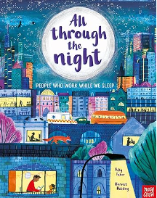  Join in with rhymes  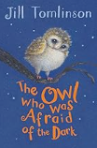 Class read over a few days | Start learning the poem ‘The owl and the pussy cat’.  The Owl babies – oral telling with props. Encourage children’s retelling of the story  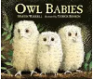  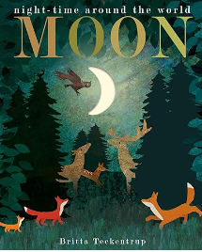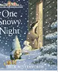 | 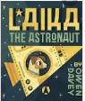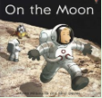   Listen to and talk about selected non-fiction to develop a deep familiarity with new knowledge and vocabulary. How is it different to a fiction book? What would you like to find out? Children come up with ‘Why?’ questions | Whole class create a space rocket outside and go on a space adventure to help the boy to catch his star  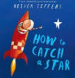  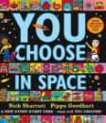  Talk partners (lollipop sticks). Which would you choose and why?  “I would choose…because”  Good listening and articulation. | Start Learning the poem ‘Cold’ by Shirley Hughes | Collaborative creation of a forest role play area. ‘Trees’ could be made out of long cardboard tubes with handprint leaves, and blue material added for a ‘river’ running through.  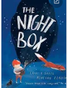
Oracy and Book Talk |  | Pictures / toys of different nocturnal animals  Who am I? Game. Model and then children have a go, first a few to the class and then to their talk partner. | 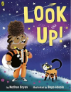 Brainstorm ways for Rocket to get her brother to stop looking at his phone and then vote with your feet. | Items you might take into space – order them from most to least important.  Articulate their ideas and thoughts in well-formed sentences.  Connect one idea or action to another using a range of connectives. | Lay out a selection of photocopied images of night spirits face up on a table/floor. Use these to play a Kim’s game: children cover their eyes, the teacher takes a night spirit away and children must then identify which one is missing. Encourage children to use adjectives to describe which night spirit is missing e.g. ‘It is the round, blue night spirit.’  Then work in talk partners. | If I were going outside in the snow I would need…  Make a list and order from most to least important and explain why – connecting each-others ideas.
Literacy |  | Share the picture book ‘Flashlight’ – children to add sentences – I can see… Encourage the use of adjectives  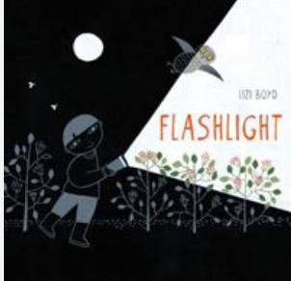  Class Project – add labels, captions and sentences to the pictures of the book ‘Flashlight’. | Continue Class Project – add labels, captions and sentences to the pictures of the book ‘Flashlight’. | 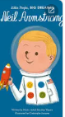 Who is Neil Armstrong? What did he do?  If you could ask him a question, what would it be?  Speech bubble questions. | 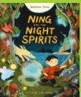 Fairy lights and lanterns hung up as children enter classroom Encourage children’s curiosity, explaining that you do not know why they are there but are trying to find out. Read an apology note from a member of staff apologising for leaving the lights out and explaining they are left out every night to keep the ‘night spirits’ away. Class creation of poster to keep night spirits away.  Letter to Ning to be brave. | Read on to, ‘afraid of what they didn’t understand’. Sort the adjectives into those that describe the night spirits (Nina) and those that don’t (townspeople).  Who do we agree with? Read the rest of the page to the end: ‘until he came up with a perfect plan’. What do children think Ning’s plan could be? Share some ideas.  Class poster for the townspeople to not be afraid.
Phonics | Reading books | Reception phonics – Unit 7 (new sounds x, y)  HFW – you  Nursery - Squiggle while you wiggle Move 1  Rhyme- Teddy bear, teddy bear  Sound discrimination and environmental sounds | Reception phonics – Unit 7 (new sounds, two letters one sound ff, ll)  HFW – said  Nursery - Squiggle while you wiggle Move 1  Rhyme- Teddy bear, teddy bear  Sound discrimination and environmental sounds | Reception phonics – Unit 7 (new sounds, two letters one sound zz, ss)  HFW- come  Nursery - Squiggle while you wiggle Move 2  Rhyme –Twinkle, twinkle  Clap back rhythms, vocal discrimination, following and giving clear instructions | Reception phonics – Unit 8 VCC and CVCC words  HFW – some  Nursery - Squiggle while you wiggle Move 2  Rhyme –Twinkle, twinkle  Clap back rhythms, vocal discrimination, following and giving clear instructions | Reception phonics – Unit 8 VCC and CVCC words  HFW – all  Nursery  Rhyme – I hear thunder  Adding music to sings, body percussion, talk in detail about sounds
Communication and Language / Phonics & Literacy Continuous Provision | Light and dark story stones  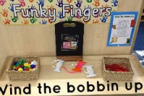 | Owl babies – puppets and book for retelling  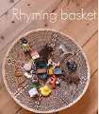  Owl writing frames | 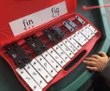  Space ship – in role play area, books about stars and planets, space suits, notepads, pens  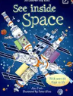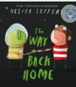  Pictures of plants, stargazing maps, writing tools | 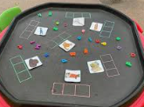  Space ship – in role play area, books about stars and planets, space suits, notepads, pens  Large black paper – space inspired drawing and labelling, planets  Designing own planet resources, with labels  Speech bubble post-its to write questions for Laika and Neil Armstrong | Blank vertical poster paper on walls and a range of writing tools e.g. paint, felt tips, crayons, pencils, so that children can continue to create their own posters using vertical writing.  Envelopes and writing paper, pens and writing frame for letter to Nina. | A small, sheltered area created with a material overhanging where Ning/the children can hide. Lanterns hung up and torches provided for children to explore.  Templates for creating a poster, word mat, book.
Physical Development - Nursery | Parachute games | Nursery – Dance  Move safely in space. Show different types of travel.  Nursery – Gymnastics  Maintain balance using hands and body to stabilise | Nursery – Dance  Listen carefully to a poem and create movements to it. Move safely in space.  Nursery - Gymnastics  Practise skills of assertion, compromise and negotiation and look to an adult for support in solving conflict | Nursery – Dance  Be creative and use different levels in our movements. Move safely in space.  Nursery – Gymnastics  Enjoys playing alone, alongside and with others and will invite others to join and attempt to join others’ play | Nursery – Dance  Work in pairs to come up with actions, using picture prompts,  Show good cooperation and listening  Nursery – Gymnastics  Maintain balance using hands and body to stabilise | Nursery – Dance  Understand what a good performance is and give good feedback  Nursery - Gymnastics  Practise skills of assertion, compromise and negotiation and look to an adult for support in solving conflict
Physical Development - Reception | Parachute games | Yoga-  Skills-I can perform a butterfly and lion post.  Knowledge- I know the importance of good breathing whilst I exercise.  Gymnastics- Flight-Bouncing, Jumping and Landing.  Skills- I can jump in a variety of ways.  Knowledge- I know to bend my leg when landing to cushion the impact. | Yoga-  Skills-Pose like a creature found in the Arctic.  Knowledge- I know about some creatures and features of The Arctic.  Gymnastics- Flight-Bouncing, Jumping and Landing.  Skills- I can jump showing good technique throughout take-off and landing.  I can control a star jump and pencil jump.  Knowledge- I know | Yoga-  Skills- I can think imaginatively. Stretch high and retain my balance.  Knowledge- I know some facts about space.  Gymnastics- Flight-Bouncing, Jumping and Landing.  Skills- I can jump through turns with control.  I can jump as part of a sequence of other movements.  Knowledge- I know what a half turn and quarter turn are.  I know to be aware of others when I am jumping. | Yoga-  Skills- I can perform a tree pose. Perform a downward dog pose.  Knowledge- I know to use my arms to help me balance. What a V shape is  Gymnastics- Flight-Bouncing, Jumping and Landing.  Skills- I can jump and show a tucked body shape in the air.  I can jump as part of a sequence of other movements.  Knowledge- I know some different jumping shapes.  I know how to jump off apparatus safely. | Yoga-  Skills- I can hold poses which depict Romans and Roman life.  Knowledge- I know more about Romans.  Gymnastics- Flight-Bouncing, Jumping and Landing.  Skills- I can change leg positions whilst I am in the air.  I can jump as part of a sequence of other movements.  Knowledge- I know the difference between a leap and a jump.  I know how to gain extra elevation.
Physical Development  Continuous Provision | Finger Gym-  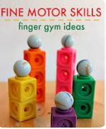  Cutting-  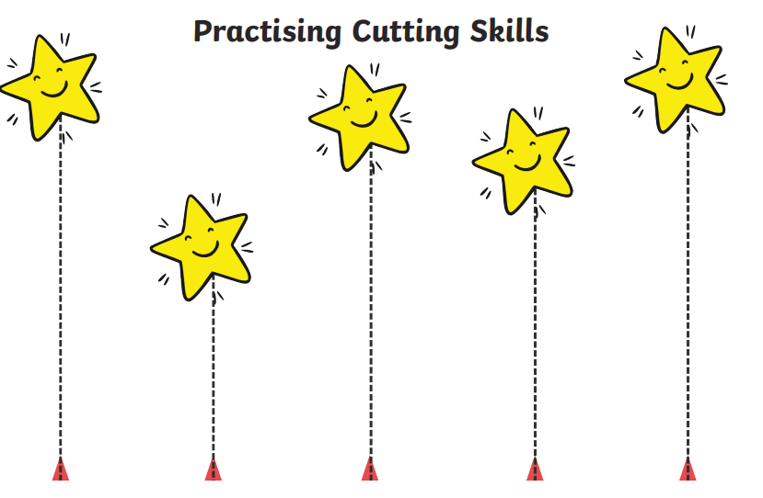 | Finger Gym-  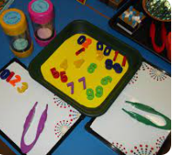  Use tweezers to order magnetic numbers  Cutting-  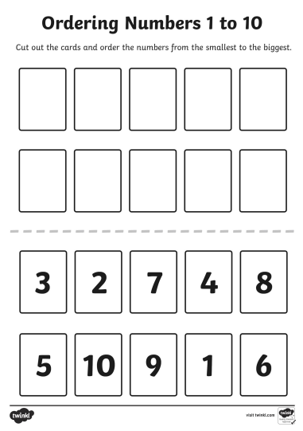  cut and order numbers 1-10 | Finger Gym-  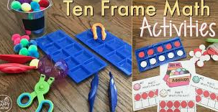  Use tweezers to place counters/pomp oms in 5/10 frames.  Cutting-  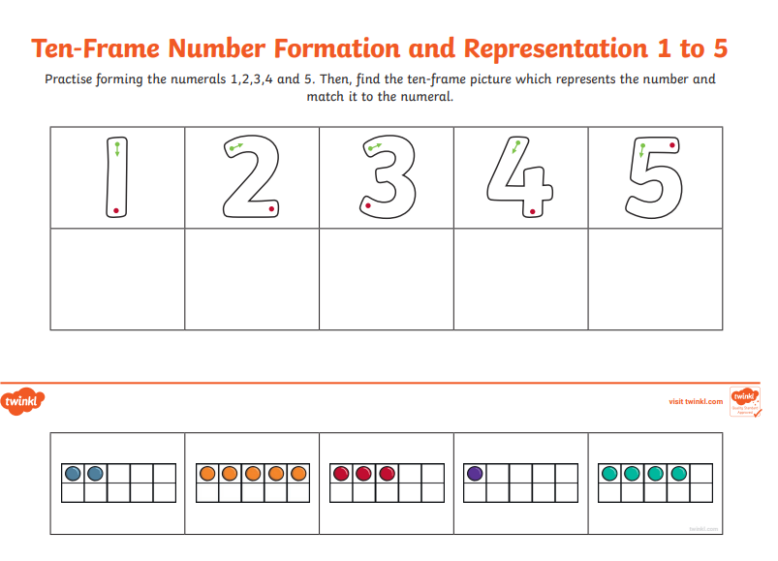  Cut and match 5 frame to number. | Finger Gym-  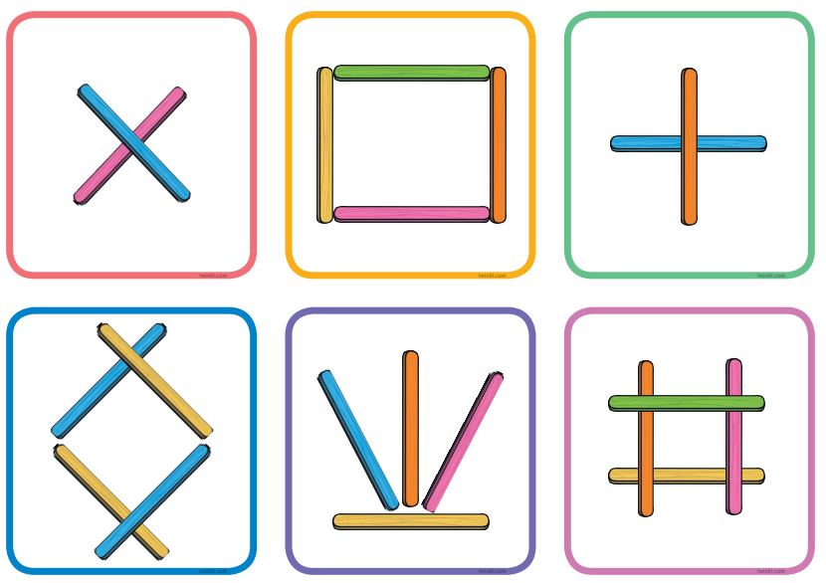  Copying stick patterns  Cutting-  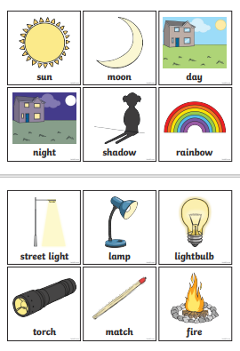  Light and dark cutting and sorting | Finger Gym-  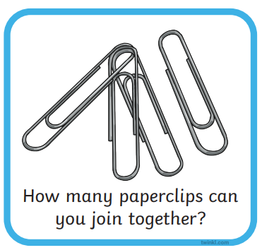  Cutting-  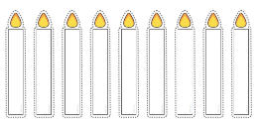    Can you cut the candles out? | Finger Gym-  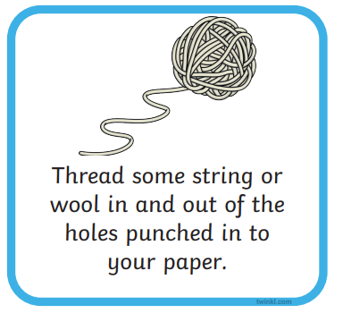  Children punch holes in card and thread wool through.  Cutting-  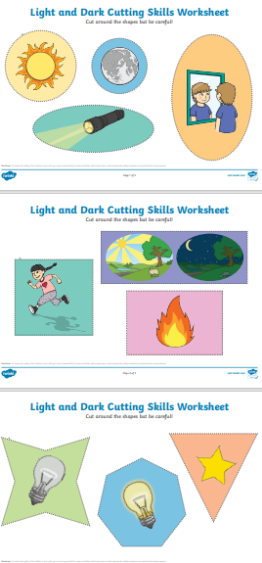  Light and dark cutting
PSED  SCARF | Keeping Safe  People who help and keep me safe | Keeping Safe  Safety Indoors and Outdoors | Keeping Safe  What’s Safe to go into my body? | Being My Best  Looking after myself | Being My Best  Looking after others | Being My Best  Looking after the environment
Mathematics | Revision and Recap.  Singing number songs  Counting games  Number recognition  2d and 3d shape | Area of Learning: Number and Pattern  Learning Strand: Counting and Ordering  Objective:  To be able to count to 10 forwards and backwards.  To understand ordinal numbers and be able to name positions e.g. first, second, third.  Vocabulary  First, second, third, fourth, fifth, sixth, seventh, eighth, ninth, tenth, last, in, between, before, after, in front, behind | Area of Learning: Number and Pattern  Learning Strand: Counting  Objective:  To represent numbers on a five and ten frame.  To match number names to numerals and to representations on ten frames up to 10.  To write numbers to 10.  Vocabulary:  Five frame, ten frame, same, different, how many, more, fewer. | Area of Learning: Number and Pattern  Learning Strand: Addition  Objective:  To use a counting strategy to combine two sets up to 10.  Vocabulary:  Sets, how many, altogether, counting, total | Area of Learning: Number and Pattern  Learning Strand: Comparing and Ordering  Objective:  To compare quantity.  To count on and back to fine 1 more and 1 fewer.  To be able to order numbers to 10.  Vocabulary:  More than, fewer than, greater, smaller, fewer, same as, group, sets. | Area of Learning: Number and Pattern  Learning Strand: Counting  Objective:  To find number bonds for numbers up to 6.  Vocabulary:  Part part whole, altogether, group, set, how many, more, fewer.
Mathematics - Nursery | Revision and recap  Singing number songs  Counting | Fives Frame Activities-  Explore different ways of making 5.  0-5 Dice activities-  Recognising numbers and counting objects 1-5 | Treasure Hunt- Counting objects and recording numbers  Skittles- Counting objects 1-1 | Saying number names in order and suing fingers to represent numbers 0-10  Counting to 5 and beyond. | Reciting number names in order and matching numbers to numerals  Sequencing numbers  Exploring a number line | Matching amounts to numbers  Making totals  Comparing amounts
Mathematics Continuous Provision | 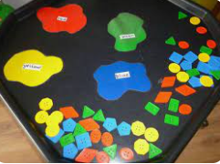  Shape and Colour recap  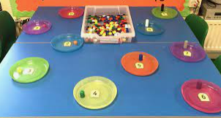  Number recognition and counting recap. | 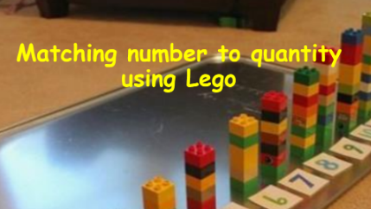  Match lego towers to numbers and order correctly  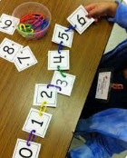  Join number cards using coloured clips. | 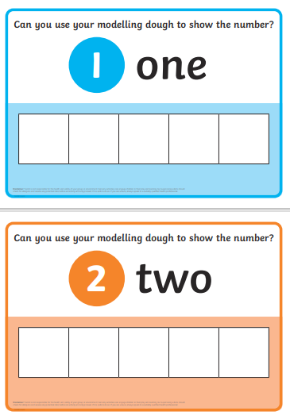  Use playdough to make balls and represent the number shown.  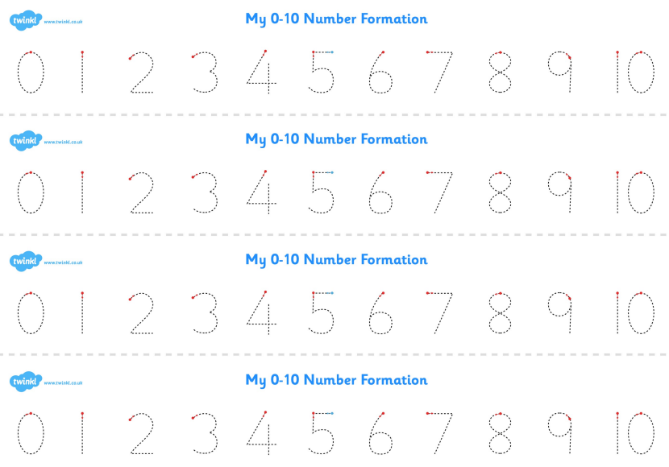  Number formation with coloured pens | 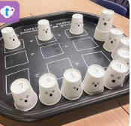  Addition using cups  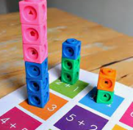  Coloured cubes and addition sums | 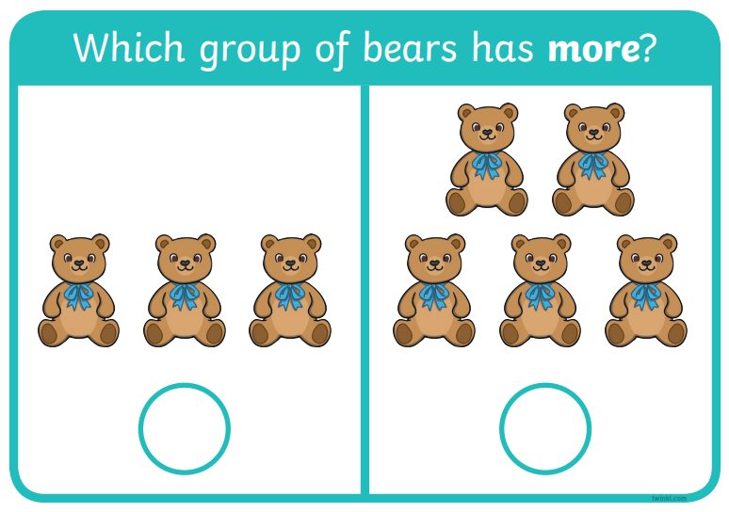  Laminate and use pegs to clip to show more/less.  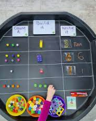  1 more/1 less using objects, number cards and numicon. | 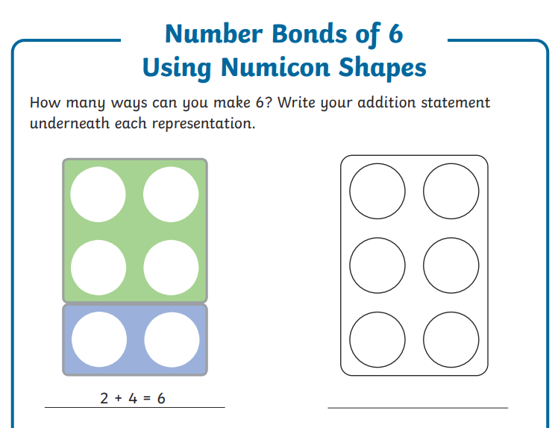  Making 6 using Numicon    Making 6- write 1 number on a wing, children need to find the other number to make 6.
Understanding the World Science and humanities |  | 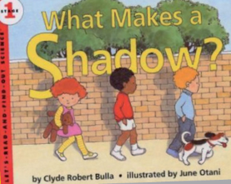  Discuss how shadows are made. | 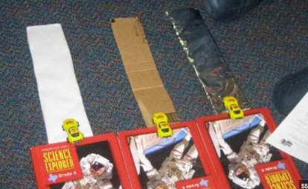  Materials and forces STEM – push forces, what happens if you push harder? How does different materials affect the distance? | Force of gravity in space - film canister rocket STEM. Different forces acting on it but ultimately the force of gravity brings it back to the ground.  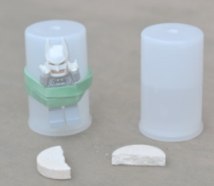 | Re-read Ning and the Night Spirits from the start up to, ‘the sky growing darker’, emphasising the sound words: ‘whisper whisper, crunch crunch, rustle rustle, whistle whistle, splish splash’. What other sounds might Ning hear outside in a forest at night? Let the children explore using the nature resources to make different sounds. What sounds can you make? Support children to orally represent the sounds they create. | 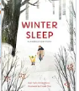Animals that hibernate and what the season of Winter looks like.  
Understanding the World Continuous Provision | Put the tray on a stand or table and drape a large, dark sheet over the top so that it covers the sides and creates a dark den underneath the tray. Add some glow sticks, torches, battery-operated candles and other sources of light for children to explore. Also, provide some sunglasses for children to wear to see if it makes their den appear even darker inside | Exploring and playing with shadow puppets  Torches and coloured liquids in lidded containers to shine the light through. | 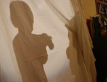 shadow play  Light box exploration. | Lollisticks catapult  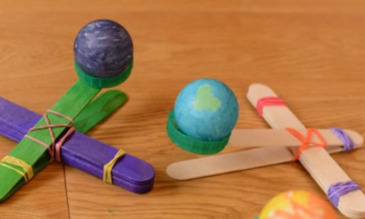  Pull force- pull down on the arm of the catapult which stores elastic potential energy, which changes into kinetic energy when released. | Black playdough with glitter for the night sky. Balls of various sizes to print onto the dough to create the solar system. | Make an igloo using ice cubes  Polar bear terrain tuff tray
Understanding the World  RE | No RE | Share a book that is special to them and talk about why it is special – do you treat it differently to your other books? | Unwrapping a Bible from Tess and Tom – talk about how it is a special book for Christians because it tell the stories of Jesus and helps them to learn how to live. Ask the children to choose a story from the Bible and talk about its special message from God for Christians.  Gratitude stones – World Religion Day   | Share the story of The Good Shepherd using small world figures and discuss what God’s message to Christians is from this story. | Create your own cover for a Bible – be able to talk about your creation and show links to what we have learned. | Look at the Qu’ran and Torah treat these respectfully. Talk about these being very special to people of Islamic and Jewish faith. How is that similar to Christians?
Expressive Arts and Design  Art and DT | Black paper and light-coloured chalk for children to explore the contrast of the light chalk on the dark paper. Encourage them to draw a night-time scene, e.g. an owl in a tree. Model how fingers can be used to rub the chalk lines to blend and shade. | Colour mixing – adding white / black to a colour and creating a colour wheel | Using white pencils on black paper to create drawings inspired by the story ‘Flashlight’ | 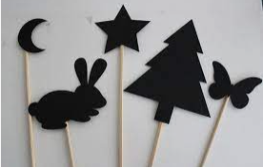 | Small world space rocket and figures |   Glow in the dark art
Expressive Arts and Design  Music and Drama | Charanga- Everyone!  Exploring: family, friends, people and music from around the world.  Musical Activities that embed pulse, rhythm and pitch, explore voices and classroom instruments. | Charanga- Everyone!  Exploring: family, friends, people and music from around the world.  Musical Activities that embed pulse, rhythm and pitch, explore voices and classroom instruments. | Charanga- Everyone!  Exploring: family, friends, people and music from around the world.  Musical Activities that embed pulse, rhythm and pitch, explore voices and classroom instruments. | Charanga- Everyone!  Exploring: family, friends, people and music from around the world.  Musical Activities that embed pulse, rhythm and pitch, explore voices and classroom instruments. | Charanga- Everyone!  Exploring: family, friends, people and music from around the world.  Musical Activities that embed pulse, rhythm and pitch, explore voices and classroom instruments. | Charanga- Everyone!  Exploring: family, friends, people and music from around the world.  Musical Activities that embed pulse, rhythm and pitch, explore voices and classroom instruments.
Expressive Arts and Design Continuous Provision | Black paper and light-coloured chalk for children to explore the contrast of the light chalk on the dark paper. Encourage them to draw a night-time scene, e.g. an owl in a tree. Model how fingers can be used to rub the chalk lines to blend and shade. |  | 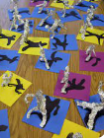  Make shadow art |  | Small world space rocket and figures
Forest School - Wednesdays | No Forest School | Take torches into the Forest (Flashlight by Lizi Boyd) and minibeast pots – what can we see in the daytime. Children take photos of what they find to create a class collage of the ‘Forest School in Daylight’  Owl babies – making owlets  Selection of beaters for making music outside | Place some Animal Silhouette Cut-Outs on the ground and sift flour around the outside. Carefully remove the template to reveal the animal shape.  Whittle nocturnal animals  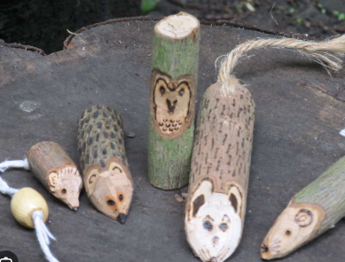 | No Forest School | Ning and the Night Spirits – miniature carved wood furniture and craft resources for making spirits.  Mini envelopes and note-paper, pencils  Willow lanterns | Cooking – popcorn (noticing how the kernals change)  Owl and hedgehog whittling  Willow lanterns

