
EYFS English Curriculum Overview 2023/2024 Stanton St Quintin Primary School and Nursery

Children’s choice will lead three of the terms, so texts and themes will be subject to change. However quality texts will always be chosen if substituting any of the below, with a balanced breadth of authors and genres being provided.
2023-24 | Term 1  Outside/Inside | Term 2  Superhero’s I know  REME | Term 3  Light/Dark  We are the Curious | Term 4  Explorers  Orienteering Day | Term 5  Amazing Animals  Wild Place Project | Term 6  Once Upon a time  (Traditional Tale from another country)  On sight fun day
 | 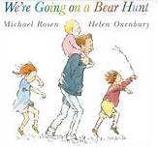  We’re Going on a Bear Hunt  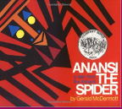  Anansi the Spider  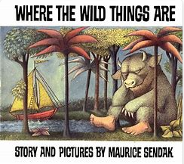  Where the wild things are. | 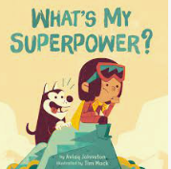  What’s My Superpower?  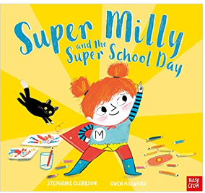  Super Milly and the Super School Day  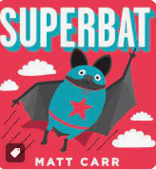  Superbat | 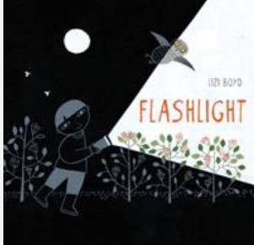  Flashlight- Lizzie Boyd  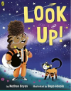  Look Up  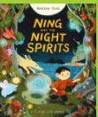  Ning and the Night Spirits | 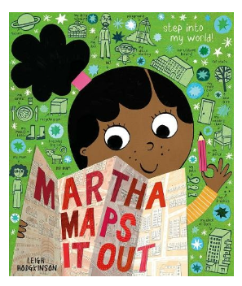  Martha Maps it Out  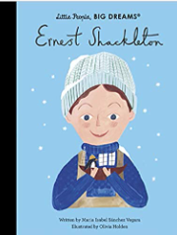  Ernest Shackleton  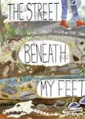  The Street beneath your feet | 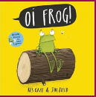  Oi Frog  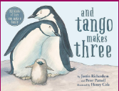  And Tango makes three  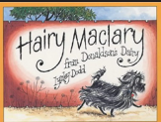  Hairy Maclary from Donaldson’s Dairy | 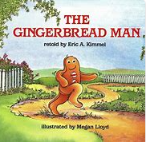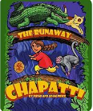  The Gingerbread Man  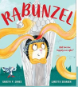  Rabunzel  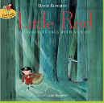  Little Red
Nursery Rhymes & Poetry | Incy Wincy Spider  African call and response song – Che Che Kule | Miss Polly had a Dolly  Dr Foster went to Gloucester  John Brown’s Baby | Twinkle twinkle little star  Whether the weather  I hear thunder  Raining Flowers by Michael Rosen | A sailor went to sea, sea, sea  Row, row, row your boat  Sea Shanty – The Wellerman | 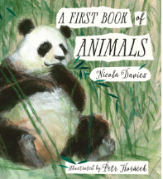Poems from A First Book of Animals by Nicola Davies  Fuzzy Wuzzy | Grow Up! By James Carter  Fee fi fo fum  The house that Jack built
Word Reading | Letters and Sounds – Phase 1  Environmental sounds  Instrumental sounds  Body percussion  Voice sounds  Sounds Write – Initial code (a, i, m, s, t, n, o, p, b, c, g, h, d, e, f, v),  VC and CVC words  Interventions |  | Letters and Sounds Phase 1  Environmental sounds  Instrumental sounds  Body percussion  Voice sounds  Sounds Write – Initial code (k, l, r, u, j, w, z, x, y, ff, ll, ss, zz)  VC and CVC words  Interventions |  | Letters and Sounds  Oral blending and segmenting  Rhythm  Rhyme and alliteration  Sounds Write – vcc, cvcc, ccvc, ccvcc, cvccc, cccvc words.  Sh, ch, th, ck, wh, ng, qu  Interventions
Comprehension | -Listen to a story and comment on events.  -Name the characters from a familiar story.  -Identify the characters and settings of a familiar book.  -Join in with repeated refrains from a familiar story.  -Begin to use language from a story when discussing it.  -Sequence a familiar story using images or objects.  - Listen to a story and comment on events.  -Name the characters from a familiar story.  -Join in with repeated refrains from a familiar story.  -Make a simple prediction based on the events of a story so far. |  | -Listen to a story and comment on events.  -Name the characters from a familiar story.  -Identify the characters and settings of a familiar book.  -Begin to use language from a story when discussing it.  -Sequence a familiar story using images or objects.  -Tell the story to another person using the book or images,  -Make a simple prediction based on the events of a story so far.  -Use the language from a story within role-play and discussions.  -Listen to a story and comment on events.  - Identify the characters and settings of a familiar book.  -Begin to use language from a story when discussing it.  -Make a simple prediction based on the events of a story so far.  -Anticipate (where appropriate) key events in stories.  -Use and understand recently introduced vocabulary during discussions about stories, non-fiction, rhymes and poems and during role-play. |  | -Listen to a story and comment on events.  -Name the characters from a familiar story.  -Identify the characters and settings of a familiar book.  -Join in with repeated refrains from a familiar story.  -Begin to use language from a story when discussing it.  Sequence a familiar story using images or objects.  -Tell the story to another person using the book or images,  -Make a simple prediction based on the events of a story so far.  -Use the language from a story within role-play and discussions.  -Demonstrate understanding of what has been read to them by retelling stories and narratives using their own words and recently introduced vocabulary.  -Anticipate key events in stories.  - Use and understand recently introduced vocabulary during discussions about stories, non-fiction, rhymes and poems and during role-play. | -Listen to a story and comment on events.  -Name the characters from a familiar story.  -Identify the characters and settings of a familiar book.  -Join in with repeated refrains from a familiar story.  -Begin to use language from a story when discussing it.  -Demonstrate understanding of what has been read to them by retelling stories and narratives using their own words and recently introduced vocabulary.  -Anticipate key events in stories.  -Recycle familiar stories verbally (or in written form) recalling the structure of the original story.  -Substantiate their predictions and opinions with evidence from the story.  Use newly acquired language from books in different contexts.
Oracy Progression | I can use talk in play to practise new vocabulary.  I can look at someone who is talking to me. | I can speak audibly so I can be heard and understood.  I can speak in full sentences. | I can use gestures to support meaning in play. | I can make relevant contributions and ask questions.  I can describe events that have happened to me in detail. | I can take turns to speak when working in a group and listen to others.  I can use ‘because’ to develop my ideas. | I can join phrases with words such as ‘if’, ‘because’, ‘so’, ‘could’ and ‘but’.
Writing Focus  To develop writing skills, every opportunity will be taken to encourage in the moment writing, which will be child-led and not necessarily related to the current theme or text. | Mark Making  Ascribe meaning to marks  Name writing  Write some initial sounds- Design and label wild thing | Name writing with correct letter formation  Use letter sound knowledge to write CVC words  Form letters correctly | Form all letters correctly.  Use letter sound knowledge to write CVCC and CCVC words.  Write short sentences using capital letters and full stops.  Re read sentences to check for sense.  Write known HF words | Write CCVCC, CVCCC, CCVC words.  Apply know letter sounds knowledge to the writing of simple sentences- capital letters/full stops  Re read sentences to check for sense. | Form all letters correctly  Write known HF words  Apply letter sound knowledge in writing, including 2 letters 1 sound.  Write simple phrases and sentences that can be read by others.  Include adjectives in sentences | Write a series of short sentences.  Use and, but, so, because to link sentences.  Edit work using a purple polisher.
Other Texts | 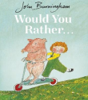    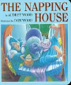 | 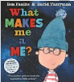  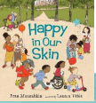 | 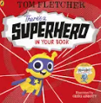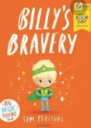  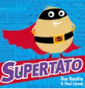 | 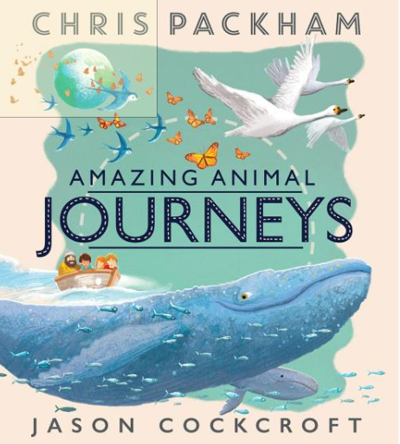  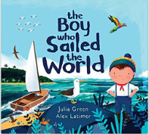  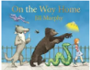 | 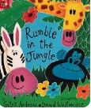  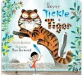  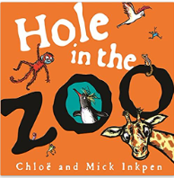 | 

