Langley Fitzurse C of E Primary School

Amaze, Excite and Inspire
Let us help each other to love others and do good. Hebrews 10:24
Stanton St Quintin Primary School
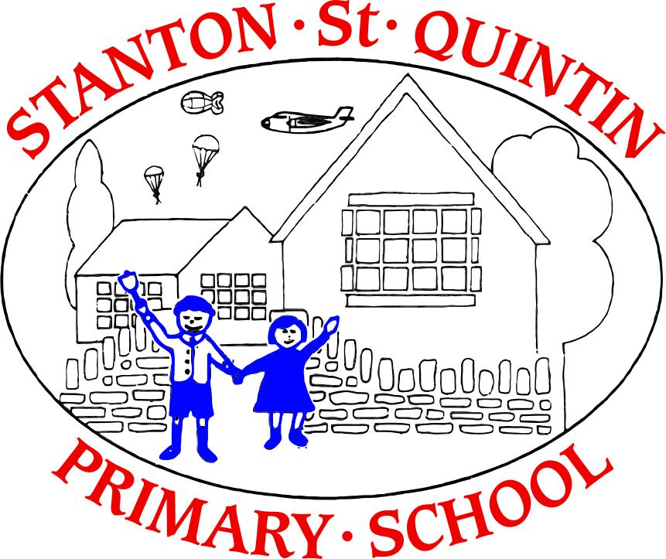

To Motivate Educate and Nurture

Stanton St Quintin Primary School
Langley Fitzurse C of E School

Early Years Foundation Stage Policy

Policy and Procedure: EYFS Policy
Date of Approval: March 21
Review date: March 23

Contents:
Statement of intent
- Aims
- Legal framework
- Roles and responsibilities
- Learning and development
- The learning environment and outdoor spaces
- Assessment
- Working with parents and carers
- Safeguarding and welfare
- Information and records
- Monitoring and review
- Admissions

Statement of intent
At Stanton St Quintin and Langley Fitzurse Schools, we greatly value the importance of the Early Years Foundation Stage (EYFS) in providing a secure foundation for future learning and development.
This policy has been developed in conjunction with the relevant Department of Education guidance and legislation to ensure that each child has a happy and positive start to their school life and from which they can develop a love of learning.
We ensure that children learn and develop well and are kept healthy and safe. We promote teaching and learning to ensure children’s ‘school readiness’ and give children a broad range of knowledge and skills that provide the right foundation for good future progress through school and life.
We seek to provide:
- Quality and consistency, so that every child makes good progress and no child gets left behind.
- A secure foundation through learning and development opportunities which are planned around the needs and interests of each child and are assessed and reviewed regularly.
- Partnership working between practitioners and parents.
- Equality of opportunity and anti-discriminatory practice, ensuring that every child is included and supported.

Aims
  - Through the implementation of this policy, we aim to:
- To provide a safe and nurturing environment where children are happy and have opportunities to explore and grow.
- Encourage children to develop independence within a secure and friendly atmosphere.
- Support children in building relationships through the development of social skills such as cooperation and sharing.
- To develop a positive partnership between home and school.
- To ensure all children feel happy, safe and valued members of the class.
- Help children develop their powers of expression and a love of acquiring knowledge through play, exploration and investigation.
  - Four guiding principles shape our practice:
- Every child is a unique child, who is constantly learning and developing in their own way.
- Children learn to be responsible, respectful and caring towards others.
- Children learn and develop in enabling environments, carefully designed to respond to their individual needs.
- There is a strong partnership between the school and parents.

Legal framework
  - This policy has due regard to statutory legislation, including, but not limited to, the following:
- Childcare Act 2006
- The Safeguarding Vulnerable Groups Act 2006
- The GDPR
- Data Protection Act 2018
- Childcare Act 2016

  - This policy has due regard to statutory guidance including, but not limited to, the following:
- DfE (2017) ‘Statutory framework for the early years foundation stage’
- DfE (2020) ‘Keeping children safe in education’
- DfE (2018) ‘Working together to safeguard children’
- DfE (2015) ‘The prevent duty’
- DfE (2014) ‘School Admissions Code’
- DfE (2012) ‘School Admission Appeals Code’
- DfE (2018) ‘Early education and childcare’
- DfE (2018) ‘Early years entitlements: operational guide’

  - This policy is intended to be used in conjunction with the following school policies:
- Behaviour Policy
- Special Educational Needs and Disabilities (SEND) Policy
- Teaching and Learning Policy
- Child Protection and Safeguarding Policy
- Online Safety Policy
- Health and Safety Policy
- Data Protection Policy
- Photographic and Video at School Policy
- Complaints procedure

Roles and responsibilities
  - The governing board has the overall responsibility for ensuring there is a policy in place to safeguard children that includes an explanation of the action to be taken when there are safeguarding concerns about a child, the use of mobile phones and cameras, and staff safeguarding training requirements. Please refer to the school’s Child Protection and Safeguarding Policy and Photographic and Video at School Policy.
  - The EYFS Lead, in conjunction with the headteacher, has responsibility for the day-to-day implementation and management of this policy.
  - Staff, including teachers, support staff and volunteers, are responsible for familiarising themselves with, and following, this policy.

Learning and development
  - All staff are committed to a creative, whole-school approach.
  - The EYFS curriculum is based on an observation of children’s individual needs, interests and stages of development.
  - In partnership with parents, the school promotes the learning and development of pupils to ensure they are ready for the next stage of education.
  - There are seven areas of learning and development that must shape education programmes in EYFS settings (Updated EYFS 2021). These are split into two sections – prime and specific; however, all the sections are interconnected and important.
  - The ‘prime’ areas of learning and development are:
- Communication and language
- Listening and attention
- Speaking
- Personal, social and emotional development
- Self-regulation
- Managing Self
- Building Relationships
- Physical development
- Gross Motor Skills
- Fine Motor Skills

  - The ‘specific’ areas of learning and development are:
- Literacy
- Comprehension
- Word Reading
- Writing
- Mathematics
- Number
- Numerical Patterns
- Understanding the world
- Past and Present
- People, Culture and communities
- The Natural World
- Expressive arts and design
- Creating with Materials
- Being imaginative and Expressive
  - Activities are planned to reflect children’s interests and individual circumstances in order to provide each child with a challenging and enjoyable experience.
  - The school will respond to each child’s emerging needs and interests, guiding their development through warm, positive interaction.
  - Phonics and maths are taught daily.
  - Indoor and outdoor activities are planned to develop children’s individual skills and interests. with regard to three characteristics of effective teaching and learning in the EYFS (Updated EYFS 2021):

• Playing and exploring - children investigate and experience things, and ‘have a go’

• Active learning - children concentrate and keep on trying if they encounter difficulties, and enjoy achievements

• Creating and thinking critically - children have and develop their own ideas, make links between ideas, and develop strategies for doing things
  - Where a child may have additional needs, staff consider whether specialist support is required, linking with the school SEND practitioner and relevant services from other agencies, where appropriate.
  - All children are valued as individuals irrespective of their ethnicity, culture, religion, home language, background, ability or gender.

The learning environment and outdoor spaces
  - The classroom is organised in such a way that encourages children to explore and learn in a safe environment.
  - Children have access to an enclosed outdoor play area, with a range of opportunities to promote learning.
  - Children participate in Woods Learning/Field and Forest, which is planned to enrich their learning and development in all areas of the EYFS.
  - There are two toilet facilities available to the EYFS, and there are hygienic changing facilities located near Darling class (SSQ).

Assessment
  - At Stanton St Quintin and Langley Fitzurse Schools , ongoing assessment is an integral part of the learning and development process, enabling the schools to recognise children’s progress, understand their needs, plan activities, and assess the need for support.
  - Methods of Observation include:
- Daily observational jottings noting children’s significant achievements and recording what they say.
- Planned focused observations and analysis.
- Photographic and video evidence.
- Children’s learning journey are recorded either electronically or as a paper journal.
  - At the beginning of Reception, all children are assessed according to the government Baseline Assessment alongside teacher assessments.
  - Termly summative assessment records children’s progress for each of the 17 Early Learning Goals.
  - At the end of EYFS, staff complete the EYFS Profile for each child. Each child is assessed against the 17 early learning goals, indicating whether they are:

Meeting expected levels of development.

Not yet reaching expected levels (‘emerging’).

Working with parents and carers
  - At Stanton St Quintin and Langley Fitzurse Schools , we firmly believe that the EYFS cannot function without the enduring support of parents and /or carers. Our aim is for parents and / or carers to be partners in their child’s learning and to be fully informed of their child’s progress.
  - Parents and / or carers are invited to termly parents’ evenings; however, the school has an open-door policy and parents are welcome to talk to teachers at the end of the school day, with any queries or immediate needs.
  - Parents and / or carers are asked to sign permission slips for any visits out of school, use of photographs of their child and using the internet at school.
  - Parents and / or carers are kept up to date with their child’s progress and development. The EYFS profile helps to provide parents and / or carers with a well- rounded picture of their child’s knowledge, understanding and abilities.

Safeguarding and welfare
  - All necessary steps are taken to keep the children in our care safe and well.
  - Any safeguarding or welfare issues will be dealt with in line with the Child Protection and Safeguarding Policy, and all members of staff in the EYFS are required to read this policy as part of their induction training.
  - All accidents and injuries are recorded and any first-aid treatment administered to a child will also be reported to their parents. See the school Health and Safety Policy.

Information and records
  - Information is stored in line with the GDPR and the Data Protection Act 2018, and further details can be found in the school’s Data Protection Policy.

Monitoring and review
  - This policy is reviewed every two years by the headteacher, EYFS Lead and the governing body.
  - Any changes made to this policy will be communicated to all members of staff.
  - All members of staff directly involved with the EYFS are required to familiarise themselves with all processes and procedures outlined in this policy as part of their induction.
  - The next scheduled review date for this policy is March 2023.

Admissions
11.1 A warm welcome awaits you and your child as we embark on an exciting journey together.
11.2 Information about each child, is gathered from parents and carers and other Early Years settings. This information is used to help teachers to plan activities to support each child’s transition.
11.3 It is typical for children’s first few weeks to include half days and sessions to support their transition. Transition information will be shared with parents and carers before their child begins their school journey.
11.4 Any child who is having difficulty settling, or whose behaviour causes concern may have their entry delayed or re-organised following discussions with parents / carers.

Admissions - Reception
11.5 Children are admitted to school in accordance with the County Admissions Policy. Please note this direct quote from Wiltshire Council:
‘From September 2011, all reception age children are offered full time places when they start primary or infant school. In previous years, those born between 1 April and 31 August attended on a part time basis for at least a term.
If parents want their child to attend part time from September or to delay entry until later on in the academic year, they must contact the school directly to arrange this.’

Admissions - Nursery
11.6 Children attending Stanton Nursery will be permitted at any time after their 3rd birthday. Those joining before their 15 hours free childcare begins will pay for the sessions their child attends.
Access to the universal 15 hours free childcare will be permitted the term after a child’s third birthday:
- Born between 1 January-31 March: eligible from the start of term beginning on, or following, 1 April after the child’s third birthday
- Born between 1 April-31 August: eligible from the start of term beginning on, or following 1 September after the child’s third birthday
- Born between 1 September-31 December: eligible from the start of term beginning on or following 1 January after the child’s third birthday

11.7 Parents wanting to access the universal 15 hours free childcare do not need to apply for this through the digital childcare service.

11.8 Parents wanting to access the 30 hours free childcare entitlement must do so through the digital childcare service.

