The lion, the witch &the wardrobe (review)
Imagine yourself walking into a normal wardrobe and discovering a magical winter wonderland…….
Peter, Susan, Edmund and Lucy were evacuees and were staying at Professor Kirk’s wealthy home. The four adventured to find a mysterious peak wardrobe that had a frozen world inside.
The scenery was spectacular; you could relax and be stunned. You would expect someone dressed up in a lion costume wouldn’t y ou? Aslan was beautiful origami style lion which had three men controlling the gargantuan creation. I could feel myself on the edge of my seat and getting dragged into the characters emotions. 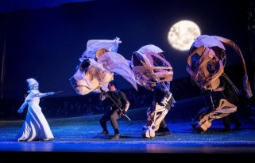
Thomas Aldridge and Sophia Nomvete (Mr & Mrs Beaver) stunned the audience with their powerful voices and their life like characteristics. As you step further into the story the stone table cracked and Aslan disappeared. It was undiscovered by the viewers which leaves a trail of mystery in your mind. I couldn’t think of a negative thing to say except from that I couldn’t hear very well. The singing was beautiful and clear. Whilst the orchestra blew me away, Adrian Mitchell (the director)did a fantastic version of C.S. Lewis’s book, even outside of the performance I was stunned! As it was advent they had doors and when you open it you find a picture from the production. The lighting made the scene transparent at times which moved the story along. 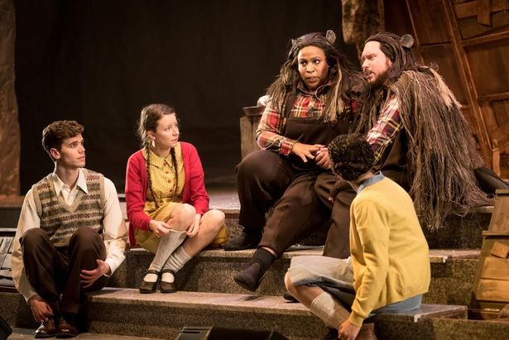
The use of puppets was phenomenal, Grumpskin was creative as Danielle Bird crouched down behind the puppet. I personally liked Mrs Beaver (Sophia Nomvete) because she had exactly the voice and was the best actor I’ve EVER seen!
I recommend it to everyone, but not everyone would be fond of it. It’s good for families and schools.
Rating:
Daisy said “It was amazing WOW!”
By Jade

